Update Client (Pepper)

Note:
1. Update service should be added as a startup service during setup.

Database Schema (Settings table)

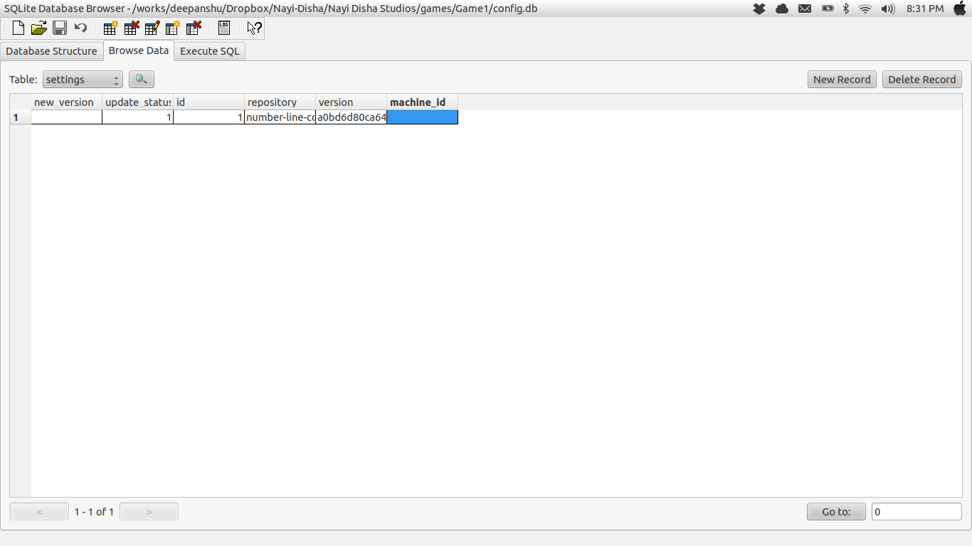
The 'repository' field should be set for each game and all the games should be updated with the commit hash of the current 'version' in the database.

